Sra. Martinez Hampton Bays High School

Name_________________________________

**Unidad 1: Introducción al estudio del medio ambiente**

Capítulo 1 y 2- Chapter 1 and 2

**Método Científico- Scientific Method:**

**Pasos del método científico- Steps of the scientific method**

1.

2.

3.

4.

5.

6.

7.

**Teoría- Theory:**

**Ley Científica- Scientific Law**

**Unidades de medida estándar Internacional- Standard International Measurement Units**

¿Cuál es la unidad estándar para cada uno de estos? What is the standard unit for each of these?

Metro (________)- **m**- La unidad estándar para________________ (____________)

Gramo (________)- **g**- La unidad estándar para________________ (________)

Litro (_________)- **l**- La unidad estándar para_________________ (__________)

**Prefijos comunes del SI- Common SI prefixes**

|  |  |  |  |
| --- | --- | --- | --- |
| **Prefijo- Prefix** | **Símbolo- Symbol** | **Valor Numérico** | **Valor Decimal-** |
| Mega |  |  |  |
| Kilo |  |  |  |
| Hecto |  |  |  |
| Deka |  |  |  |
| Deci |  |  |  |
| Centi |  |  |  |
| Milli |  |  |  |
| Micro |  |  |  |
| Nano |  |  |  |

**Escalas de Temperatura- Temperature Scales**

|  |  |  |  |  |
| --- | --- | --- | --- | --- |
| Escala- Scale | Bp of water | Fp of water | Body Temp | Room Temp |
| Fahrenheit |  |  |  |  |
| Celsius |  |  |  |  |
| Kelvin |  |  |  |  |

Absolute Zero- The temperature **where molecules stop moving**

Cero Absoluto- La temperature donde **las moléculas dejan de moverse**

**00 Kelvin or -2730C**

**Tipos de Microscopios- Types of Microscopes**

Light Microscope: Any device (**aparato)** that uses ________to produce an enlarged view of an object.

Simple Microscope – The first microscopes had only one lens. They used ____________ _____________ to produce an image. Also known as a ______________________ they could magnify (**magnifica)** up to _______x.

Compound Microscope – Utilizes (**utiliza)** _________ lenses. One lens produces an enlarged image (**imagen engrandecida)** that is further ___________________ by the second lens. A compound microscope has a _________________, two ______________ and a ____________system for adjusting (**ajustar)** the focus (**enfoque)** and image (**imagen).**

**Terminología Microscopio- Microscope Terminology**

**Magnification**- A measure (**medida)** of how much the image is magnified  
Total Magnification= objective lens x ocular lens

Ex. Eyepiece or ocular lens (10x) x Objective lens (40x) = ______

**Resolution**- The clarity (**claridad)** of an image.

**As magnification______________, resolution __________________.**

**Field of View**

**As you increase (aumentas) the magnification, the size of the background (fondo) or *field of view* _________________.**

**Microscope Function**

Microscope Part

Function of Microscope Part

Eyepiece (ocular)

Magnifies the image- Aumenta la imagen

Arm

Support the upper microscope parts and used to carry the microscope

Body Tube

Objective lens

Course Adjustment Knob

Fine Adjustment Knob

Nosepiece

 Holds (detiene) the objective lenses

Stage

Stage Clips

Diaphragm

Lamp or Light Source

Base

Pivot

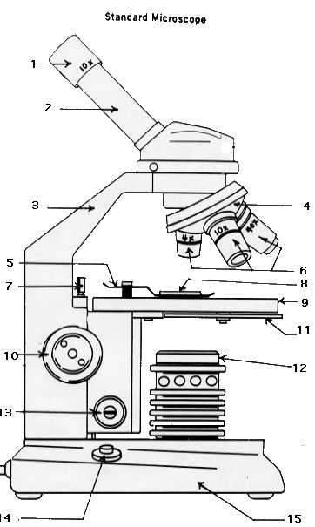

**Laboratory Techniques- Técnicas de laboratorio**

**Centrifugation (centrifugación): Materials spin (giran) and are separated based on their __________. The particles with a higher density in the liquid will push themselves to the bottom of a test tube that has been spun in a centrifuge.**

**Electrophoresis (electrophoresis): The technique for separating molecules of DNA that have an __________________. The distance each fragment moves in an electrical field is dependent upon the ___________of the molecules in the substance.**

**Micro-dissection: A ______________________ is attached to the microscope stage that allows a doctor to use tiny ____________to perform various operations on living things.  
Ex. Cloning**

**Ex. Microsurgery**

**Chromatography (cromatografía): A method used to separate & identify chemical substances based upon differences in _______________in a solvent**.

**Tissue Culture: The technique of maintaining ______________ or tissues in a culture medium outside the __________.  
Ex. Growing embryos in a test tube  
 skin grafts (injertos de piel)**